|  |  |  |  |
| --- | --- | --- | --- |
| **Group Number:** | Group 9 | |  |
| **Assignment Title:** | Group Project | |
| **Course Code:** | RSM 8224 | |
| **Instructor Name:** | Scott Liao |  |
|  |  | |
|  |  | |
|  |  | |

|  |  |  |  |
| --- | --- | --- | --- |
|  | | | |
|  |  |  |  |
|  | 1002365512 |  | 1001755031 |
|  | 1000841958 |  | 1001104743 |
|  | 1006118443 |  |  |

# **Executive Summary**

The purpose of this report is to utilize cross-sectional forecasting models to evaluate different firms annual earnings; comparing the predicted earnings with analysts’ forecasts in order to assess predictive capability. The *Fundamentals Annual* dataset from Compustat and *Guidance* dataset from IBES were used, both sourced from WRDS[1], to gather the necessary financial information and analyst forecasts, in order to generate the required variables.

There are four different earnings forecasting models that were evaluated: *HVZ, Random Walk, Earnings Persistence & Residual Income*. Those models were developed using guidance from (Li & Mohanram, 2014)[2], as well as in-class explanations. Further that, the best model, which was found to be *HVZ*, was chosen and modified in order to potentially provide improvements; via manipulation of other predictor variables. Upon developing the optimal earnings forecasting model, it was then applied to 10 different firms stocks in order to predict Earnings per Share (EPS) and evaluated against analysts’ forecasts. Finally, the improved *HVZ* model was then applied to various industries in order to evaluate the top 10 firms in terms of earnings for the year 2019.

Contents

Executive Summary 1

Modelling Earnings 3

Random Walk Model 3

HVZ Model 4

Earnings Persistence Model 5

Residual Income Model 6

Model Evaluation 7

Improvements to HVZ Model 8

Improved Model Implementation 11

Firms Chosen for Analysis 12

Earnings Forecasting Results 16

Forecasting Best Performing Firms 17

Using Improved HZ Model 17

Using Improved HVZ Model with Industry Specific Coefficients 18

# **Modelling Earnings**

Earnings data was sourced from the *Fundamentals Annual* dataset from Compustat, the firms chosen were publicly traded on the New York Stock Exchange or American Stock Exchange (Exchg Codes 11 & 12). The time period for analysis was chosen to be 2010 – 2015, this differs from the time period used by (Li & Mohanram, 2014) which ranged from 1969 – 2012. Thus, upon comparing the developed earnings models to the research paper, a one to one comparison would be difficult to achieve, however the developed models should follow the same characteristics and provide similar insights (i.e. sign of coefficients should be the same).

## Random Walk Model

The first model is the naïve Random Walk Model, this is a simple time series model that regresses the firms future earnings on current earnings during the training period. Some of the benefits of the Random Walk Model is its simplicity and high interpretability, a user can easily understand how a firms earnings have fluctuated over a certain time period. Conversely, the drawbacks of the Random Walk Model are: Firstly, since it is a time series model there is scarce data per firm, there are only four quarters per year and for a 5-year period that only provides 20 observations; the models generalizability would essentially be very low due to lack of training observations. As well as that, due to the extreme simplicity of the model, a user would not be able to fully understand the drivers of earnings and as a result the results may mislead their decisions. Nonetheless, the model serves as a benchmark for predicting future earnings and is a good comparison to more complicated ones. The fundamental expression for the Random Walk Model is: *Earningst+1 = Earningst + ε*, upon running the regression the results were: *Earningst+1 = 58.45 + 0.8341*Earningst*. The standard errors associated with the intercept and coefficient were: *11.38* and *0.06* respectively, indicating that both were statistically significant. Moreover, the results intuitively follow the momentum theory, whereas if a firm is performing well in the past it will continue to do so in the future and vice versa, this is evident from the positive coefficient on *Earningst.*

## HVZ Model

The HVZ Model incorporates cross-section analysis which considers multiple firms across a time period, this significantly increases the amount of data available for training as well as utilizing the most recently available data which can reduce the overall bias of the model by better estimating current economic conditions. The general expression for the HVZ model is:

*Earningst+1 = Total Assetst + Dividend Paymentst + Firms paying dividends (1 or 0)t + Earningst + Negative Earnings (1 or 0)t + Total Accrualst.* The benefit of including these variables in the model are: Firstly, total assets accounts for the heterogeneity between firms in terms of their size and allows for more approximate earnings per firm depending on their current size of operations, the dividend payments amount and dummy variable account for firms that are paying dividends and how much; this is beneficial since typically firms that start paying dividends are in good standing and as a result will potentially have higher earnings than others. The negative earnings dummy accounts for the fact that firms that are potentially doing worse in the past will tend to change their strategy in order to improve future performance, and finally total accruals captures the firms reported accruals which is linked to the idea of future earnings reversal based on high/low accruals. Upon running the regression, the obtained results are shown below in *Figure 1*.

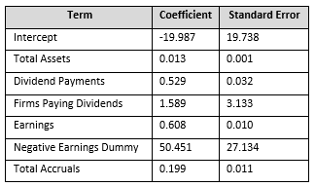

Figure 1 - Results from HVZ

As seen from the coefficients, having more assets, or being a larger firm, is generally more indicative of higher future returns, similar to firms that are paying dividends. The model seems to significantly award firms that have reported negative earnings in prior years and predict much higher future earnings. This large coefficient on the negative earnings dummy may also be linked with the negative intercept, which indicates that essentially all firms are benchmarked to have negative earnings at the beginning and having all the additional variables in the model will tend to elevate their earnings value to a positive value. Finally, the expectation is that the total accruals coefficient would be negative to account for the reversal effect, however the opposite is true. This may attribute to the sample set used (2010 – 2015) in which there may have been less earnings management than in prior years, and thus lower accruals to reconciliate between earnings and operating cash flow. Another explanation for the positive accruals coefficient is that the sample period directly follows the 2008 recession in which firms may have been generally reporting lower earnings and not having sufficient liquidity in terms of operating cash flow.

## Earnings Persistence Model

The Earnings Persistence model further simplifies the HVZ model by simply considering the autocorrelation between earnings throughout the years, as well as the differential correlation between past negative earnings and future earnings. The underlying hypothesis behind this model is to include a firms negative prior earnings with the assumption that if poor performance foregoes the current year then there is a high chance that management will reconsider their operational strategy in order to improve performance, and as a result increase future earnings. The general expression for the Earnings Persistence model is:

*Earningst+1 = Negative Earningst + Earningst + Neg. Earningst * Earningst*

Upon running the model on the data, the following results were obtained for each of the coefficients (results in *Figure 2*). For a firm that has generated a positive earnings of $1000 in the past, it can be seen that they are expected to generate approximately $891 in the following year. Conversely, for a firm that has a loss earnings of $1000, they are expected to generate around $227 in the following year; thus following the previously stated hypothesis that: when firms experience poor performance they tend to re-evaluate their strategy for the following year and as a result it can be expected that the firm will have positive earnings.

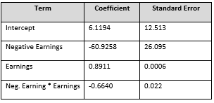

Figure 2 - Results from EP Model

## Residual Income Model

A further extension to the Earnings Persistence model is the Residual Income model which incorporates additional terms in order to better predict earnings based on the firms underlying performance. The first change is the addition of the book value of equity, as oppose to dividends in previous models. Both dividends and book value of equity suggest that a firm is performing well and generating revenue, however the book value term is more advantageous in the sense that it captures the underlying assets of the firm which may prove to be more consistent in providing returns as oppose to dividend payments. Additionally, the accruals were also included in this model to account for the idea of accrual reversal and the ability to capture the firms underlying future earnings. The general form of the Residual Income model is as follows:

*Earningst+1 = Neg. Earningst + Earningst + Neg. Earningst * Earningst + Book Value Equity + TACCt*

The results from the coefficients in *Figure 3* below follow the same methodology as before in terms of the autocorrelation between earnings and the negative accrual coefficient which indicates the reversal effect. The book value of equity also seems to be statistically significant in predicting future earnings which indicates that there is more underlying financial information captured in that variable pertaining to earnings, as oppose to dividends.

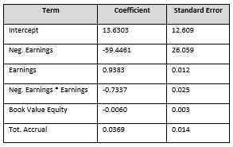

Figure 3 - Results from RI Model

# **Model Evaluation**

In order to assess the precision of all the base models generated the following metrics were evaluated as shown below in *Figure 4*. All the models have a similar value for the adjusted R-Squared indicating that they all explain around 70% of the variance in the data for predicting future earnings. It is noted that the adjusted R-Squared value can be considered to be high within this application of earnings prediction; however, seeing that the data used for training spanned a 5-year duration it is expected that most of the variance can be explained with these simple models. Furthermore, two other measures were used to evaluate the models: Bias and Accuracy. Those measures compared the model predictions relative to the actual earnings reported by companies for the year of 2017. The random walk can be seen to provide the most optimistic prediction which in turn is the least accurate; attributed to the simplicity of the model. On the other hand, both the HVZ and Residual Income models seem to have similar accuracy measures, however the HVZ is more optimistic in terms of predictions, which means it overshoots the actual earnings value with higher magnitude. Thus, the most precise model is chosen to be *HVZ*; even though the bias measure is not the best relative to other models, the accuracy is however the lowest which indicates that *HVZ* is best at providing predictions that are within close range of actual earnings reported, and considering the objective of these models in terms of earnings forecasting that is the most important metric.

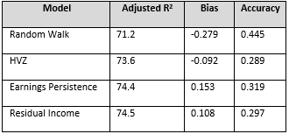

Figure 4 - Results from all models

# **Improvements to HVZ Model**

As an extension to the base HVZ model, additional feature variables were included such as dummy for negative accruals, interaction term between actual accrual value and negative accrual dummy, firm’s current capital expenditure and the delta or change in current earnings as compared to previous year earnings. After multiple iterations with different combination of additional predictor variables, it was found that Negative Accrual dummy and Change in earnings as a proxy for firm’s past performance added significant explanatory power to predict future earnings. It was also noticed that with extra features, the dummy for dividends in the base HVZ model resulted to be statistically insignificant and hence was omitted from the improved model. In terms of quantifying the model performance, the extended HVZ model had brought down the absolute bias in magnitude from 0.28 to 0.18 and improved the adjusted R-Square by around 2.1% (R2 of improved model is 75.5%). From theory it is known that reduction in the absolute bias value is equivalent to a proportional increase in the prediction accuracy, i.e., the estimated future period earnings is as closely predicted to the analyst’s forecasts. The improved HVZ model took the form of: *Earningst+1 = Total Assetst + Dividendst + Earningst + Accrualst + (Earningst-1 – Earningst) + (Liabilitiest-1 – Liabilitiest)*, the resulting coefficients and standard errors are shown below in *Figure 5,* as seen all coefficients are statistically significant in predicting future earnings. Moreover, also shown in *Figure 6* is a correlation heatmap depicting the interactions between different terms in the model. The variables included seem to be highly correlated with the future earnings of a firm and tend to explain most of the variance underlying the earnings for the following year. Following the inferences from base model, the current period earnings has more weightage in estimating future period earnings. For the delta earnings, it clearly captures the earnings momentum effect where if a firm is previously doing well it will continue to do so. In addition, the accruals coefficient still maintains a negative coefficient which coincides with the reversal nature of accruals and earnings prediction. Moreover, the change in liabilities also carries a negative coefficient. This term indicates that the more liabilities: such as debt or accounts payable, a firm takes over they become prone to more risk and as a result future earnings might be negatively impacted due to that risk.

|  |  |
| --- | --- |
| Figure 5 - Results of Improved Model | Figure 6 - Correlation Heatmap for Model |

In order to further validate the improved HVZ model developed, additional to the pooled regression, an industry wise rolling regression model was also developed based on OLS. This helped capture the variation in the effects of each coefficients based on their general industry behavior and benchmark the company’s performance within the sector it belongs to. The exercise was done across all four base models mentioned in the previous section and based on the model performance estimates, bias and accuracy, it was noticed that the improved HVZ model performed better for majority of the industries, as seen from *Figure 7*. It is also observed that the industries that reported the random walk model as being the most accurate had much less observation relative to others; thus, using a more sophisticated model with more parameters seemed to perform worse because there were not sufficient variables to provide predictive power.

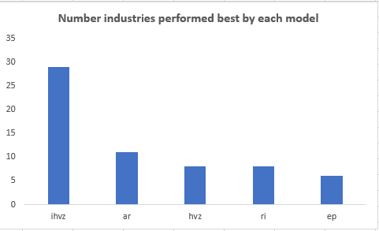

Figure - Results of Rolling Regression per Industry

# **Improved Model Implementation**

In order to validate the developed model, a set of 10 different companies were chosen and the earnings forecasting model developed in the previous section was applied to their 2016 financial results in order to predict the 2017 Earnings per Share. The companies chosen varied in both industry and size; in order to expose the model to a spectrum of financial information and assess accuracy relative to analyst forecasts. Some of the benefits of using analysts forecasts as a benchmark is that they incorporate some non-public information (i.e. conference calls, manager meetings) as well as an array of previous industry experience, in their forecasts. This information cannot be quantified in analytical models and as a result analyst forecasts tend to be slightly more accurate, or close to the true value of future earnings. Conversely, the benefit of using an analytical model for earnings forecasting is the much faster exchange and interpretation of information, this allows analytical models to have a leading edge in providing more quicker forecasts before all the information is digested by the public; as a result, traders can capitalize on inefficient markets and generate return.

## Firms Chosen for Analysis

The companies chosen for analysis are as follows: The first company is Lili’s Energy (ticker: LLEX), which is an oil & gas exploration and production firm located in Fort Worth, Texas. As shown from *Figure 8* the company had started seeing a decline in stock price over the last 4 years, in addition from *Figure 9* it can be seen that analyst forecasts have been on par with report earnings during the last couple of years. One of the main reasons that attributed to the company’s declining performance is the fluctuation in oil prices during the last year, which resulted in numerous defaults on loans[3]. The main reason this company was chosen was due to its asset heavy balance sheet, which could provide some insight into future earnings.

|  |  |
| --- | --- |
| Figure 8 - LLEX Past Performance | Figure 9 - EPS Forecasts for LLEX[4] |

The second company is Tegna Inc. (ticker: TGNA) which is a digital media and marketing firm based in Virginia. Over the last 4 years the company has also seen a decline in Net income by around $200,000 each year, as shown in *Figure 11*, which has also impacted their stock price that has dropped in value over the last 3 years, but recently has started to recover *(Figure 10)*. This company was chosen based on the higher values of goodwill and intangible assets on the balance sheet due to the nature of their business; this might provide some insight into future earnings.

|  |  |
| --- | --- |
| Figure 10 - TGNA Stock Performance | Figure 11 - Earnings Performance (x100) |

The third company, Hexcel (ticker: HXL) is an industrial materials manufacturing firm based in Connecticut. The firm relies on transforming raw materials into finished product such as carbon fiber and epoxy resin; thus, it was chosen due to the potentially high levels of inventories in the process (RM to WIP to Finished Goods). As shown in both *Figure 12 & Figure 13* below, the stock price of the company seemed to be stable during the last year and analyst forecasts seemed to exhibit high error further away from earnings announcement and then readjust as the day got closer. Also, analyst forecast for the stock price also has high variance of around 25% of the mean price.

|  |  |
| --- | --- |
| Figure 12 - Actual Stock Price Last Year | Figure 13 - Forecasted Stock Price Last Year |

Fourthly is a gold & mineral mining and investment firm called Franco Nevada Group (ticker: FNV). Similar to the oil & gas company above, this company was also chosen due to its potentially higher assets due to commodity trading, equipment ownership & PPE; in order to see the effect on earnings. During the 2017 & 2018 period analyst forecasts for this company seem to be within 5-10% of the actual resulting value, as shown below in *Figure 14.*

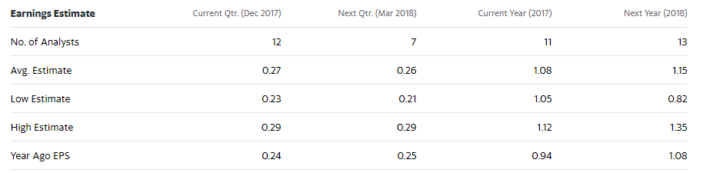

Figure 14 - Forecasted & Actual EPS[5]

Next is a company called Nautilus (ticker: NLS) based out of Vancouver, B.C. This company specializes in the manufacturing and distribution of fitness equipment and are heavily involved in the wellness and fitness industry. The firm has seen around a 90% loss in stock price over the previous 5 years, in addition analysts have been on par with forecasting negative EPS, however their estimates are off by as much as 50% of the actual price in some cases; seen in *Figure 15.*

|  |  |
| --- | --- |
|  |  |

Figure 15 - EPS & Stock Price[6]

Ellerston Global Investments (ticker: EGI) is the next firm, which is an investment firm. Throughout the last 5 years the stock price is seen to be constant without significant changes in price *(Figure 16)*. In addition, this firm was mainly chosen due to cash flows from investments as well as potentially higher liabilities on the balance sheet.

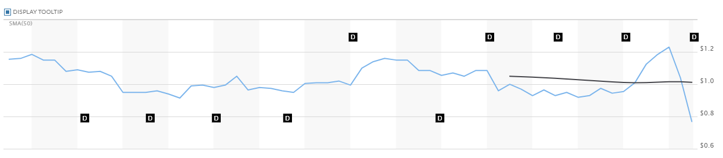

Figure 16 - Stock Price[7]

Moreover, Tenneco (ticker: TEN) is a gas transmission company based out of Illinois. Even though this company is involved in similar industries as previous firms chosen, the main purpose of forecasting their earnings was due to their size. Tenneco is a fortune 500 firm with almost $9 Billion in annual revenues; the ability for the developed model to accurately forecast EPS for a firm of such magnitude can prove that the model does indeed capture the majority of the components involved in generating earnings within firms of all sizes. Manpower Inc. (ticker: MAN) is another fortune 500 firm that was chosen. This firm specializes in human resource, professional and staffing services worldwide. This firm was also chosen due to its difference in industry from other firms, in order to understand whether an industry type might have any influence on the predictive accuracy of the developed model.

The firm is Time Warner (ticker: TWX) which is a media and entertainment company; a subsidiary of Warner Brothers. The firm was chosen due to its intricate involvement with many other companies and platforms such as: CNN, HBO, Bell, Crave and more. The hypothesis is that the earnings for this company are potentially controlled by other subsidiaries and their performance will significantly impact future earnings. Shown below in *Figure 17* is the report and forecasted EPS for the last 5 years, as seen the analyst forecasts are on par with reported numbers and the bias of their estimates is fairly low.

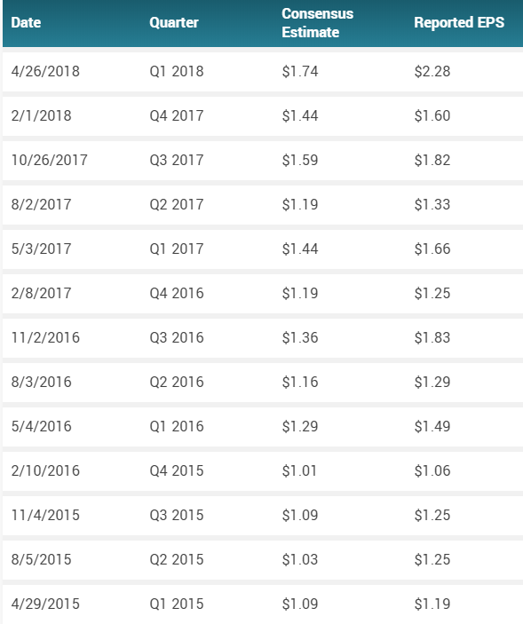

Figure 17 - EPS Forecasts[8]

## Earnings Forecasting Results

It is evident from *Figure 18* below that upon using the model to forecast EPS for 2017 for the chosen firms, the forecast error relative to analyst forecast are around 20%, with the exception of one company that is around 95% off. Also, the model does tend to over & under-estimate the EPS almost evenly between the firms which indicates that the variables used in the model do not systematically predict in a single direction.

One reason that can be attributed to the high forecast error for LLEX is the sudden drop in stock price and earnings around 2017 (displayed above in *Figure 8*), it is possible that this was an unexpected loss that could have been controlled by external “soft” factors that were not captured by the model; as a result the analysts forecasts tend to perform much better in this scenario.

Conversely, the firm with the lowest forecast error is NLS (fitness equipment manufacturer and distributor). One reason for the high performance of the model is that this firm would typically be asset intensive which is captured by the total assets variable in the model, as well as there might be some changes in accruals that may stem from operating cash flow; seeing that this is a firm that is potentially selling fitness equipment to gyms on credit, thus accruals tend to fluctuate throughout the years.

Overall, for all firms the model tends to forecast earnings per share within a reasonable offset from the analysts forecasts which indicates that: the model is capturing potentially some ‘soft’ variables which analysts use to provide forecasts, as well as the variables included in the model also tie in with the firms operations, for example: Assets, Liabilities and Accruals.

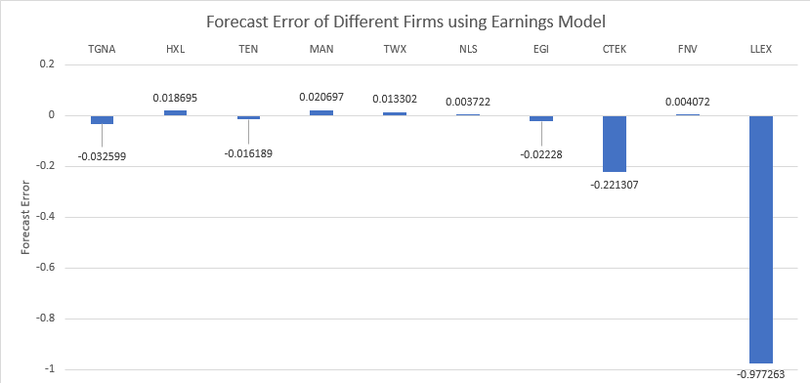

Figure 18 - Forecast Results for Firms

# **Forecasting Best Performing Firms**

## Using Improved HZ Model

By leveraging the improved HVZ model and financial data in 2018, predicted earnings and earnings growth multiples for 2019 is computed. The top ten firms that are most likely to exhibit the largest earnings growth and their predicted earnings growth multiples in 2019 are shown in *Figure 19* below.

Figure 19 - Top 10 Firms w/ Largest Earnings Growth 2019

There are two firms in 500 Fortune Company List, they are Targa Resources Corp (ticker: ARGP) and Tenneco Inc (ticker: TEN). Additionally, two of them are in the Energy industry: Targa Resources Corp (ticker: ARGP) and South Jersey Industries Inc (ticker: SJI), which means that the industry of Energy performs better than other industries in recent years. Moreover, Targa Resources Corp (ticker: ARGP) has the highest earning growth rate, it is in both 500 Fortune Company List and Energy industry. The predicted earning in 2019 for Targa Resources Corp (ticker: ARGP) is 261.34 times more than its earning in 2018.

## Using Improved HVZ Model with Industry Specific Coefficients

A second approach was also considered when predicting the top performing firms. This entailed using the improved HVZ model however, the upon running the rolling industry regression discussed in the model improvement section above; each industry displayed different coefficients that were used for prediction. The top ten firms that are most likely to exhibit the largest earnings growth and their predicted earnings growth multiples in 2019 are shown in *Figure 20****.*** Except for industry 39, the IHVZ model is the best model for the rest of top 10 firms. For industry 39, Earning Persistence model is the best.

Additionally, there is one firm in 500 Fortune Company List, it is Williams Companies Inc (ticker: WMB). Additionally, three of them are in the Energy industry and two of them are in Mining industry, which means that the industry of Energy and Mining perform better than other industries in recent years.

Figure - Top 10 Firms with Largest Earning Growth in 2019 w/ Industry Coefficients

1. https://wrds-www.wharton.upenn.edu/?_ga=2.170769248.1318211588.1583680046-1537417402.1579455618
2. Li, K. K., & Mohanram, P. (2014). Evaluating Cross Sectional Forecastinf models for Implied Cost of Capital. *Business Media New York*.
3. https://finance.yahoo.com/news/lilis-energy-receives-extension-third-101510843.html
4. https://www.nasdaq.com/market-activity/stocks/llex/earnings
5. https://finance.yahoo.com/quote/FNV/
6. https://finance.yahoo.com/quote/NLS/
7. https://www.marketwatch.com/investing/stock/egi?countrycode=au
8. https://www.marketbeat.com/stocks/NYSE/TWX/